5731095821 Wasuwat Satittamajittra

2110430 Time Series Mining and Knowledge Discovery

Final Project

1. **Dynamic Time Warping (DTW) modifications**

In this project, I implemented the DTW and tested for the 1-nearest-neighbor (1NN) classification accuracies.

The data are normalized before classified.

I used the Sakoe-Chiba band and set the window length to (length of samples / 10)

Keogh’s lower bound was also used. 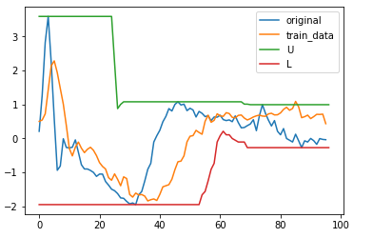

Weights(Wv, Wd, Wh) = (vertical,diag,horizantal)

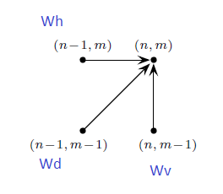

L2 norm distances were used, unless specified.

1-A. **Asymmetric Weights**

|  |  |  |  |  |  |  |  |
| --- | --- | --- | --- | --- | --- | --- | --- |
| **(Wv, Wd, Wh)/Instances** | **ECG200** | **Coffee** | **Beef** | **Beef(L1)** | **Gun_Point** | **OliveOil** | **Lightning7** |
| (1,1,1) | 1.0 | 1.0 | 0.5666 | 0.6666 | 1.0 | 1.0 | 0.808219 |
| (1,1,2) | 0.989 | 1.0 | 0.5666 | 0.6666 | 1.0 | 1.0 | 0.8356 |
| (1,2,1) | 1.0 | 0.96428 | 0.5666 | 0.6666 | 1.0 | 1.0 | 0.83561 |
| (2,1,1) | 0.979 | 1.0 | 0.533 | 0.7000 | 1.0 | 1.0 | 0.8630 |

Table1 – The classification accuracies.

There is no optimal weights for the classification accuracies in general. It depends on the instances.

1-B. **Another step patterns for DTW**

I tested on the following 3 patterns, the weights are symmetric (1,1,1).

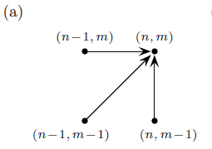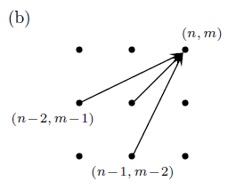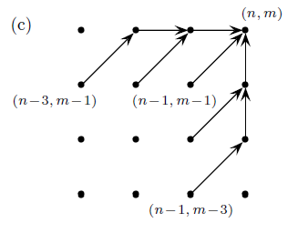

|  |  |  |  |  |  |  |
| --- | --- | --- | --- | --- | --- | --- |
| **Patterns/Instances** | **ECG200** | **Coffee** | **Beef** | **Gun_Point** | **OliveOil** | **Lightning7** |
| Pattern (a) | 1.0 | 1.0 | 0.5666 | 1.0 | 1.0 | 0.808219 |
| Pattern (b) | 0.89000 | 1.0 | 0.500 | 1.0 | 1.0 | 0.8904 |
| Pattern (c) | 0.920000 | 0.964285 | 0.5333 | 1.0 | 1.0 | 0.917808 |

Table2 – The classification accuracies.

Most instances work best on the pattern (a), except for Lightning7 that works best on Pattern (c).

1. **Shape Averaging**

I found an interesting research paper [1] about this topic. They proposed an algorithm called DTW Barycenter Averaging (DBA) method. The idea is that they want to minimize the sum of squared DTW distances from the average sequence to the set of sequences. DTW between each individual sequence and the temporary average sequence will be computed to find the associated coordinates between them. Then, each coordinate of the average sequence will be updated and used as the barycenter of coordinates associated to it. Here is the pseudocode of the algorithm.

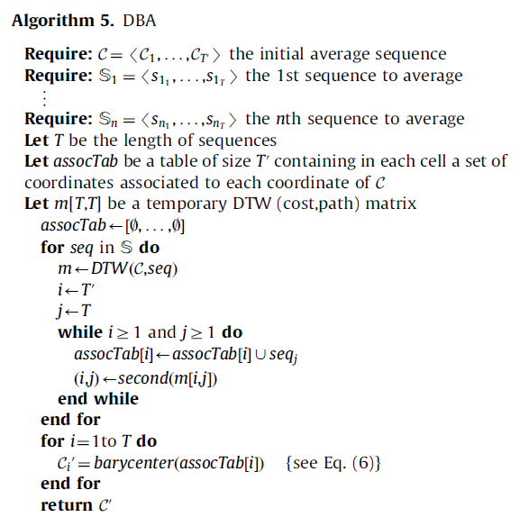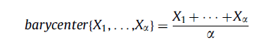

I implemented the DBA and tested on the datasets. I also shuffled the data and went through the algorithm again to see if they will give the same results regardless of the orders, and they did.

The results are shown below.

|  |  |  |
| --- | --- | --- |
| **Instances**  **Test+Train** | **Original data** | **Averaged Data** |
| **Lightning7** |  |  |
| **ECG200** |  |  |
| **Coffee** |  |  |
| **Beef** |  |  |
| **OliveOil** |  |  |
| **Gun_Point** |  |  |

Reference(s):

[1]Francois Petitjean, AlainKetterlin, PierreGanc-arski, A global averaging method for dynamic time warping, with applications to clustering, Pattern Recognition44, 678–693, 2001.